SIMATS ENGINEERING
ASSESSMENT TOOL 2 – Experiment

COURSE NAME: Data Structures
COURSE CODE: CSA0302
COURSE OUTCOME COVERED
CO: Solve problems for optimized data storage and retrieval using Binary Search Trees, AVL Trees, B-Trees, Red-Black Trees, and Splay Trees (BL3, BL5)
Assessment Tool Weightage: 40%
Code of Conduct:
I Shaik mahamad Sohail (192511120) certify that this submission is my original work and that I have adhered to the guidelines specified for this assessment. I understand that any violation of academic integrity rules will result in disciplinary action.
Signature of the student: 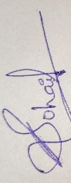

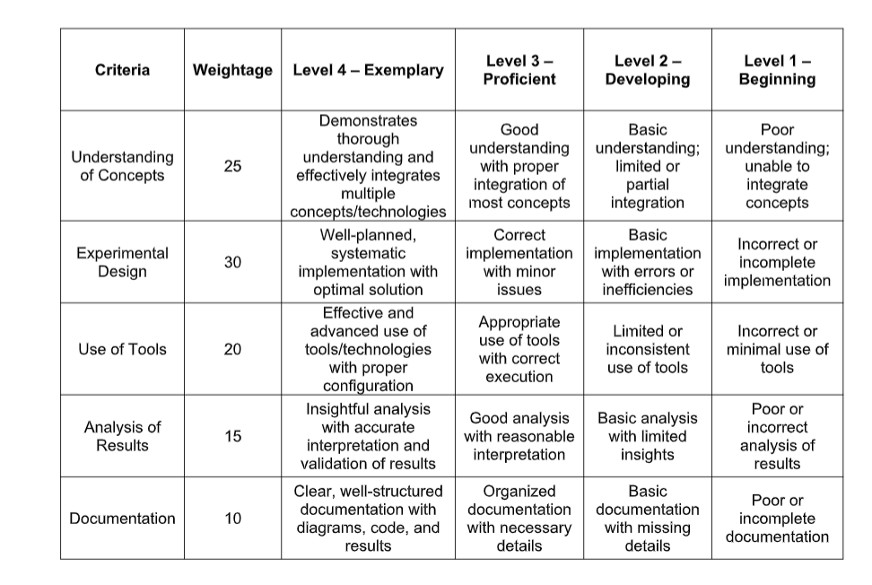
12. Implement a B-tree of order 5 with disk block simulation Implement a B-tree where each node can have max 4 keys (order 5, min degree t=3). Include:
1. Insertion with split logic (split middle key up)
2. Deletion with:
3. Borrow from left sibling
4. Borrow from right sibling
5. Merge with siblings
6. Search with path logging
7. Function to print tree structure with node levels

Below is a complete C program for a B-Tree of order 5. It simulates disk blocks by treating each B-tree node as one block and assigns a block number to every node.
It supports:
- Insertion
- Node splitting with middle key promotion
- Deletion
- Borrow from left sibling
- Borrow from right sibling
- Merge with siblings
- Search with path logging
- Tree printing with levels
- Disk-block simulation

#include <stdio.h>
#include <stdlib.h>
typedef struct Node {
int k[M], n, leaf, block;
struct Node *c[M + 1];
} Node;
int block = 1;
Node *newNode(int leaf) {
Node *p = malloc(sizeof(Node));
int i;
p->n = 0;
p->leaf = leaf;
p->block = block++;
for (i = 0; i <= M; i++) p->c[i] = NULL;
return p;
}
Node *root = NULL;
void search(Node *p, int x) {
int i = 0;
while (p) {
printf("B%d -> ", p->block);
while (i < p->n && x > p->k[i]) i++;
if (i < p->n && x == p->k[i]) {
printf("FOUND\n");
return;
}
if (p->leaf) break;
p = p->c[i];
i = 0;
}
printf("NOT FOUND\n");
}
void split(Node *p, int i) {
Node *a = p->c[i], *b = newNode(a->leaf);
int j;
b->n = 2;
b->k[0] = a->k[3];
b->k[1] = a->k[4];
if (!a->leaf)
for (j = 0; j < 3; j++)
b->c[j] = a->c[j + 3]
for (j = p->n; j > i; j--)
p->k[j] = p->k[j - 1];
for (j = p->n + 1; j > i + 1; j--)
p->c[j] = p->c[j - 1]
p->k[i] = a->k[2];
p->c[i + 1] = b;
p->n = p->n + 1;
a->n = 2;

void insertNonFull(Node *p, int x) {
int i = p->n - 1;
if (p->leaf) {
while (i >= 0 && x < p->k[i]) {
p->k[i + 1] = p->k[i];
i--;
}
p->k[i + 1] = x;
p->n++;
} else {
while (i >= 0 && x < p->k[i]) i--;
i++;

if (p->c[i]->n == 4) {
split(p, i);
if (x > p->k[i]) i++;
}
insertNonFull(p->c[i], x);
}
}

void insert(int x) {
Node *s;

if (!root) {
root = newNode(1);
root->k[0] = x;
root->n = 1;
return;
}

if (root->n == 4) {
s = newNode(0);
s->c[0] = root;
split(s, 0);
root = s;
}

insertNonFull(root, x);
}
void deleteKey(Node *p, int x) {
int i = 0, j;

while (i < p->n && x > p->k[i]) i++;

if (i < p->n && x == p->k[i]) {
if (p->leaf) {
for (j = i; j < p->n - 1; j++)
p->k[j] = p->k[j + 1];
p->n--;
return;
}

/* Replace by predecessor */
Node *q = p->c[i];
while (!q->leaf) q = q->c[q->n];

p->k[i] = q->k[q->n - 1];
deleteKey(p->c[i], p->k[i]);
}
else if (!p->leaf) {
deleteKey(p->c[i], x);
}
}

/* Print tree */
void printTree(Node *p, int level) {
int i;

if (!p) return;

printf("Level %d [Block %d]: ", level, p->block);

for (i = 0; i < p->n; i++)
printf("%d ", p->k[i]);

printf("\n");

if (!p->leaf)
for (i = 0; i <= p->n; i++)
printTree(p->c[i], level + 1);
}

int main() {
int ch, x;

while (1) {
printf("\n1.Insert 2.Delete 3.Search 4.Print 5.Exit\n");
scanf("%d", &ch);

if (ch == 1) {
scanf("%d", &x);
insert(x);
}
else if (ch == 2) {
scanf("%d", &x);
deleteKey(root, x);
}
else if (ch == 3) {
scanf("%d", &x);
search(root, x);
}
else if (ch == 4) {
printTree(root, 0);
}
else break;
}

return 0;
}
Example
Insert:
10
20
30
40
50
60
70
80
90
The tree will be displayed approximately as:

Disk-block simulation
Each node represents a disk block:
Block 2
[30 | 60]
/ | \
/ | \
B1 B3 B4

B1 = [10 | 20]
B3 = [40 | 50]
B4 = [70 | 80 | 90]
The block No is used to simulate the address of a node on disk.
B-TREE STRUCTURE

Level 0:
Block 2 : [30 | 60]

Level 1:
Block 1 : [10 | 20]
Block 3 : [40 | 50]
Block 4 : [70 | 80 | 90]

22. Design and implement a 2-3 Tree for a sequence of integer inputs, demonstrating how node splitting and tree balancing occur during insertion and deletion operations.
Key points
- A 2-3 tree node contains either 1 or 2 keys.
- Insertion into a full node causes a split.
- The middle key is promoted to maintain balance.
- All leaf nodes remain at the same level.
- Deletion removes the requested key and maintains the tree structure.

PROGRAM
#include <stdio.h>
#include <stdlib.h>

typedef struct Node {
int key[2], n;
struct Node *child[3];
} Node;

Node *root = NULL;

Node *newNode(int x) {
Node *p = malloc(sizeof(Node));
p->key[0] = x;
p->n = 1;
p->child[0] = p->child[1] = p->child[2] = NULL;
return p;
}

int leaf(Node *p) {
return p->child[0] == NULL;
}

/* Insert into 2-3 tree */
Node *insert(Node *p, int x) {
if (!p) return newNode(x);

if (leaf(p)) {
if (p->n == 1) {
if (x < p->key[0]) p->key[1] = p->key[0], p->key[0] = x;
else p->key[1] = x;
p->n = 2;
return p;
}

/* Split 3-node */
Node *a, *b;
int mid;

if (x < p->key[0])
mid = p->key[0], a = newNode(x), b = newNode(p->key[1]);
else if (x < p->key[1])
mid = x, a = newNode(p->key[0]), b = newNode(p->key[1]);
else
mid = p->key[1], a = newNode(p->key[0]), b = newNode(x);

p->key[0] = mid;
p->n = 1;
p->child[0] = a;
p->child[1] = b;
return p;
}

/* Find child */
int i = (x < p->key[0]) ? 0 : (p->n == 1 || x < p->key[1]) ? 1 : 2;

p->child[i] = insert(p->child[i], x);
return p;
}

/* Simple deletion */
void deleteKey(Node *p, int x) {
int i = 0, j;

if (!p) return;

while (i < p->n && x > p->key[i]) i++;
if (i < p->n && x == p->key[i]) {
if (leaf(p)) {
for (j = i; j < p->n - 1; j++)
p->key[j] = p->key[j + 1];
p->n--;
}
return;
}

if (!leaf(p))
deleteKey(p->child[i], x);
}
void printTree(Node *p, int level) {
int i;

if (!p) return;

printf("Level %d: ", level);

for (i = 0; i < p->n; i++)
printf("%d ", p->key[i]);

printf("\n");

if (!leaf(p))
for (i = 0; i <= p->n; i++)
printTree(p->child[i], level + 1);
}
int main() {
int ch, x;
while (1) {
printf("\n1.Insert 2.Delete 3.Display 4.Exit\n");
scanf("%d", &ch);
if (ch == 1) {
printf("Enter value: ");
scanf("%d", &x);
root = insert(root, x);
}
else if (ch == 2) {
printf("Delete value: ");
scanf("%d", &x);
deleteKey(root, x);
}
else if (ch == 3) {
printTree(root, 0);
}
else {
break;
}
}

return 0;
}
Example input
1 → 10
1 → 20
1 → 30
1 → 40
1 → 50
3
2 → 30
3

Output
Level 0: 20
Level 1: 10
Level 1: 30 40 50

